City sues owner of long-vacant south Osborne apartment block, historic downtown house

 By: Erik Pindera Posted: 4:46 PM CST Monday, Mar. 4, 2024 Last Modified: 6:02 PM CST Monday, Mar. 4, 2024 | Updates

- Share
- Print
- Email
- Read Later

Hey there, time traveller!
This article was published 04/03/2024 (442 days ago), so information in it may no longer be current.

The city is taking the owner of a controversial long-vacant south Osborne Street building to court.
The property at 270 Morley Ave., known as the Rubin Block, is a three-storey, 21-suite apartment block built in 1914. It has sat vacant — and the doors and windows have been boarded up — since a fire on the third floor in 2014.
The city’s legal services department filed the lawsuit in the Manitoba Court of King’s Bench last Wednesday, naming Composite Holdings Ltd. as defendant.
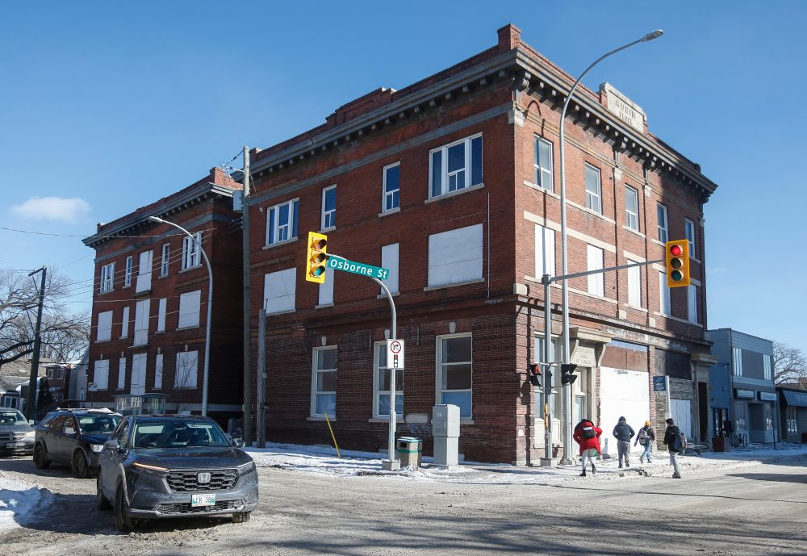 The property at 270 Morley Ave., known as the Rubin Block has sat vacant — and the doors and windows have been boarded up — since a fire on the third floor in 2014. (John Woods / Free Press)
The city is seeking $39,754 in special damages from the company, plus costs and interest. Composite Holdings has not yet filed a statement of defence in response, and a listed phone number was out of service on Monday.
The company also owns a building downtown, at 432 Assiniboine Ave., known as Mathewson House, named after the banker it was built for in 1890.
Area residents have staged rallies over the Rubin Block’s fate, calling for its rehabilitation. In 2021, about 1,500 people signed a petition urging the city to refurbish the structure so it could be used for affordable housing.
Among the signatories was Jean Altemeyer, who has lived near the apartment block since 1968.
She said Monday she’s not optimistic the lawsuit will result in much change.
“We want to see what actually happens,” she said. “The process of this lawsuit could last a long time.… It would be just godawful if that building comes down.”
Under the city’s vacant building bylaw, enforcement officers are granted powers to inspect empty properties to enforce standards, which include maintaining boards blocking unwanted access via doors and windows and basic upkeep. They also issue an annual fee for the inspection.
“I would say the city has been lax on enforcing its own rules.”– Jean Altemeyer
The bylaw also allows the city to charge owners an annual “empty building fee” worth one per cent of the most recent property assessment, after the building in question has been inspected five or more times.
“Despite demand for payment, the Morley invoices and the Assiniboine invoices are all past due and remain outstanding,” read the city’s court papers.
The city, in its court papers, claims its bylaw enforcement officers began inspecting the vacant Morley Avenue building in 2018, finding interior and exterior damage, mould in the basement and the power off, among other issues.
The city has issued invoices for inspections and the empty building fee since 2018, totalling $19,732, which have not been paid, the court papers claim.
Altemeyer was dismayed to learn the fees have allegedly gone unpaid.
“You’re kidding,” she said. “I would say the city has been lax on enforcing its own rules.”
The city’s bylaw enforcement team began inspecting the Assiniboine Avenue building in 2015, finding rotten boards in the stairs, discarded carpets, the scent of mould, holes in the floor, debris, trash and other damage, the lawsuit claims.
The city has issued nine invoices for that property, totaling $20,022; they have not been paid.
It is not uncommon for the city to take court action over unpaid fees, but lawsuits are not the first method the municipality uses to collect bills.
“In general, the city works closely with property owners to resolve bylaw and community safety issues, and only takes this step once other alternatives have been exhausted,” a city spokesman said in January.

